**Instagram User Analytics**

1. **Marketing Analysis:**

Task 1: Identify the five oldest users on Instagram from the provided database.

SELECT

*

FROM

users

ORDER BY created_at

LIMIT 5;

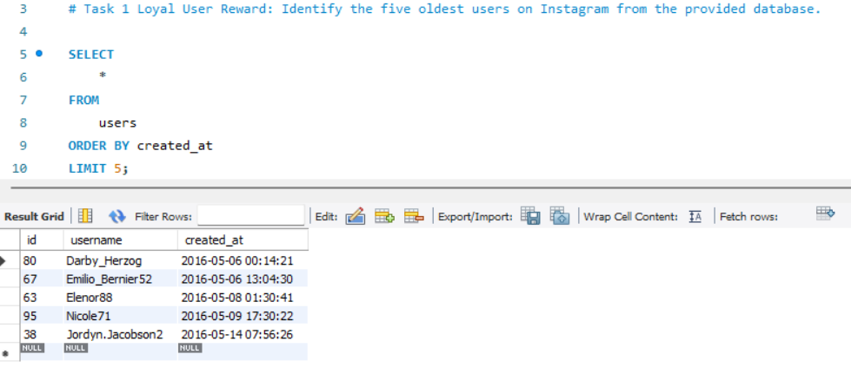

Task 2: Identify users who have never posted a single photo on Instagram.

SELECT

*

FROM

users u

LEFT JOIN

photos p ON u.id = p.user_id

WHERE

p.image_url IS NULL;

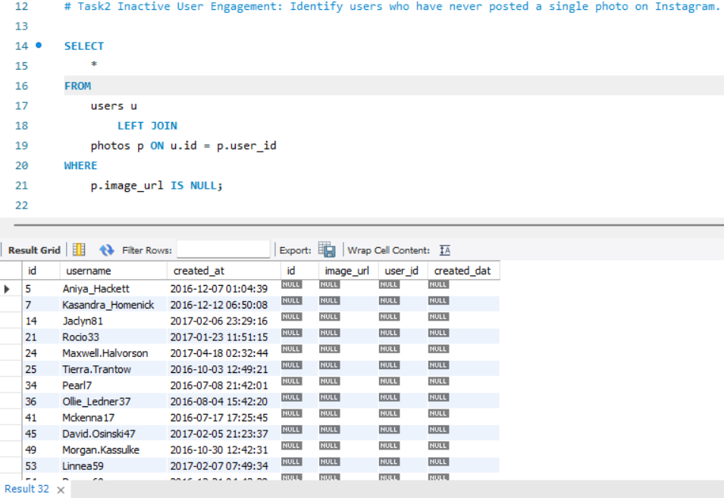

Task 3: Determine the winner of the contest and provide their details to the team.

SELECT

u.username,

l.photo_id,

p.image_url,

COUNT(l.user_id) AS Likess

FROM

likes l

INNER JOIN

photos p ON p.id = l.photo_id

INNER JOIN

users u ON p.user_id = u.id

GROUP BY l.photo_id

ORDER BY Likess DESC

LIMIT 5;

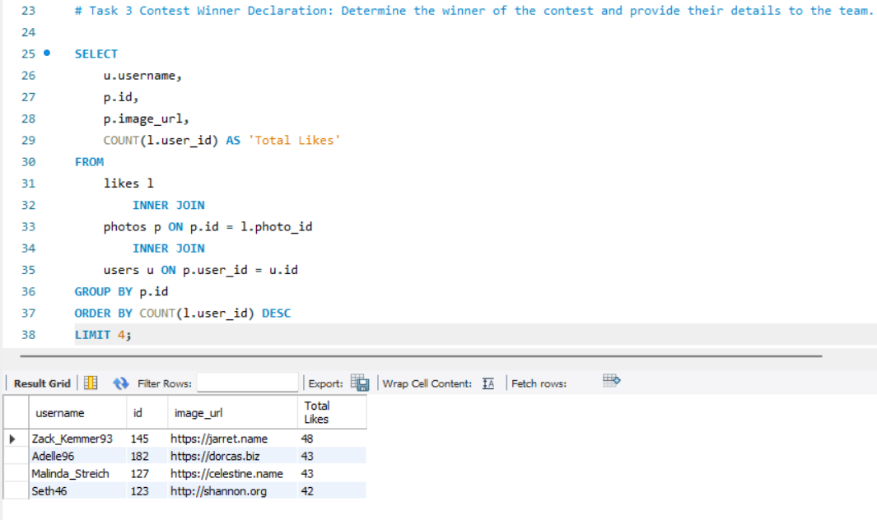

Task 4: Identify and suggest the top five most commonly used hashtags on the platform.

SELECT

t.tag_name, COUNT(pt.photo_id) AS Total_tags

FROM

photo_tags pt

INNER JOIN

tags t ON pt.tag_id = t.id

GROUP BY t.tag_name

ORDER BY Total_tags DESC

LIMIT 5;

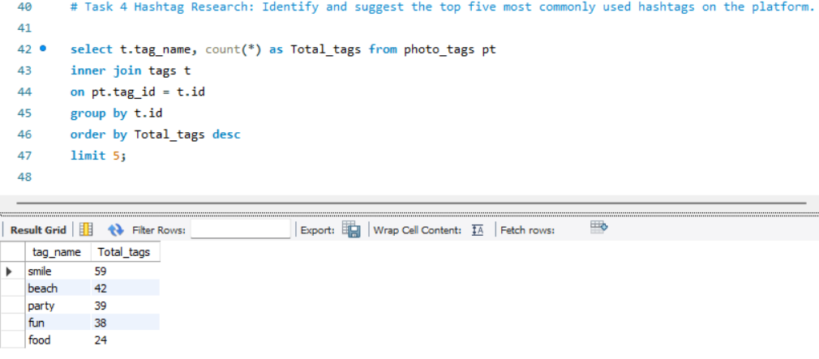

Task 5 : Determine the day of the week when most users register on Instagram. Provide insights on when to schedule an ad campaign.

SELECT

DAYNAME(created_at) AS Day,

COUNT(username) AS total_registration

FROM

users

GROUP BY day

ORDER BY total_registration DESC;

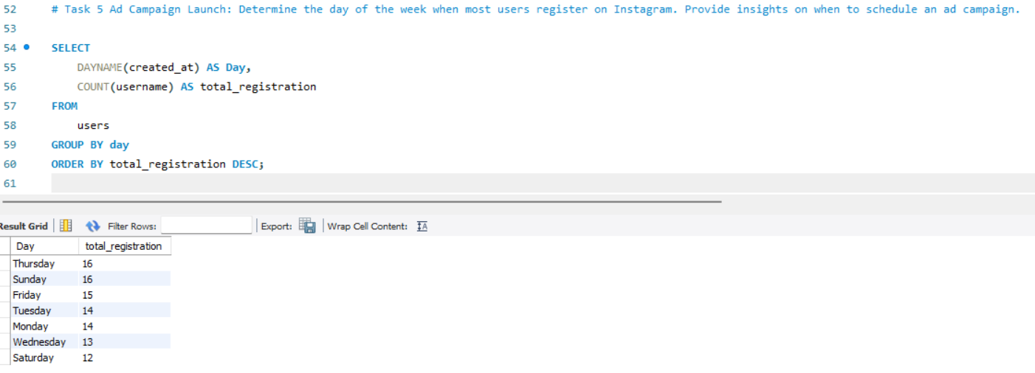

1. **Investor Metrics:**

Task 6 User Engagement: Calculate the average number of posts per user on Instagram. Also, provide the total number of photos on Instagram divided by the total number of users.

SELECT

AVG(p.id) AS avg_number_of_posts

FROM

photos p;

SELECT

AVG(u.id) AS avg_number_of_users

FROM

users u;

SELECT

ROUND((SELECT

AVG(p.id) AS avg_number_of_posts

FROM

photos p) / (SELECT

AVG(u.id) AS avg_number_of_users

FROM

users u),

1) AS avg_number_of_posts_per_user;

SELECT

SUM(p.id) AS total_number_of_posts

FROM

photos p;

SELECT

SUM(u.id) AS total_number_of_users

FROM

users u;

SELECT

ROUND((SELECT

SUM(p.id) AS total_number_of_posts

FROM

photos p) / (SELECT

SUM(u.id) AS total_number_of_users

FROM

users u),

1. AS total_number_of_posts_per_user;

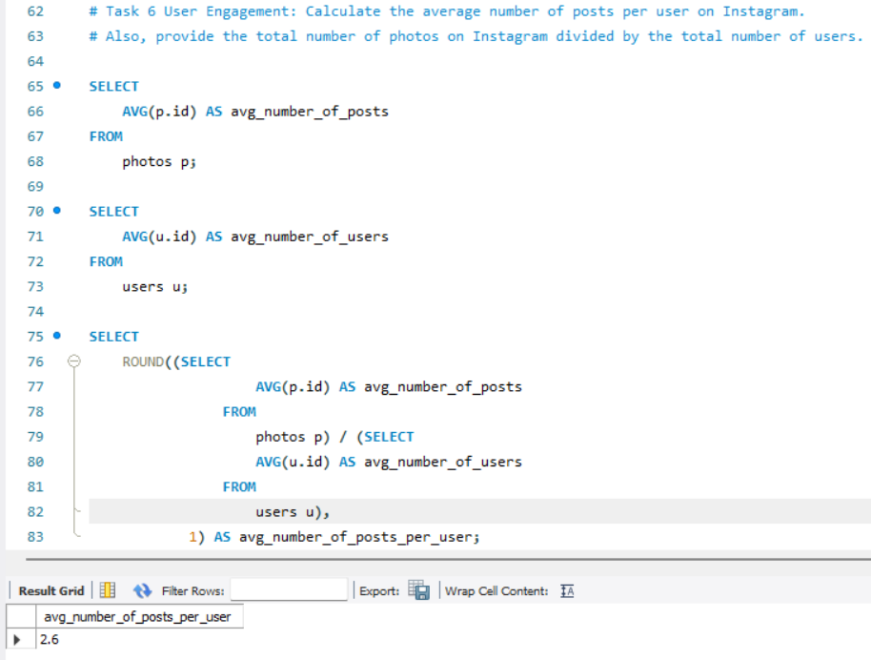

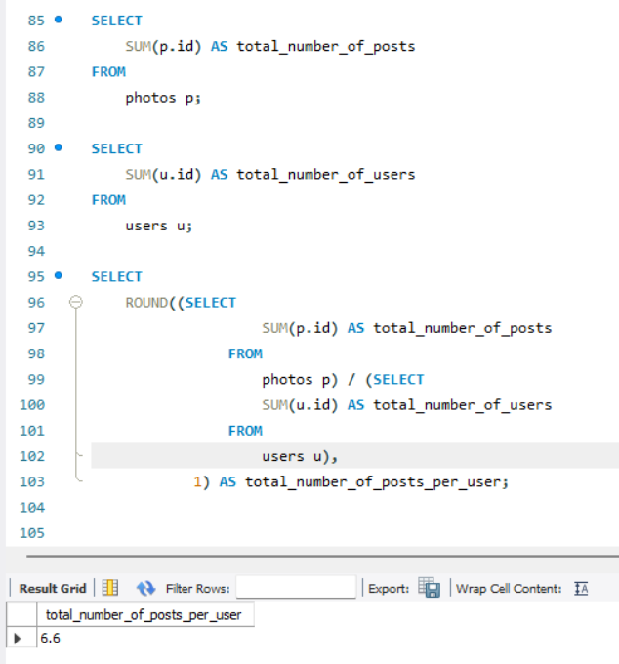

Task 7 Bots & Fake Accounts: Identify users (potential bots) who have liked every single photo on the site, as this is not typically possible for a normal user.

SELECT

u.id, u.username, COUNT(u.username) AS Total_likes

FROM

users u

JOIN

likes l ON l.user_id = u.id

GROUP BY u.id

HAVING Total_likes = (SELECT

COUNT(*)

FROM

photos p);

